Austin Stephens

Assignment_04

2/15/17

4-02.) My program successfully counts down from 100 to 1 by tens. I included a separate print statement for one just because you can’t get to one by subtracting tens and the prompt said to count from 100 to 1.

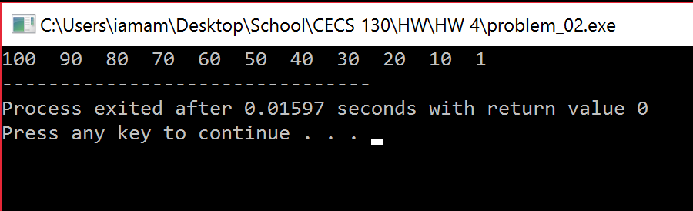

4-03.) My program successfully takes the number of questions desired from the user and gives the user that many questions. I have two variables, correct and incorrect, keeping track of how many questions the user got right and wrong. The prompt didn’t specify which math questions to ask so I made my quiz a multiplication quiz.

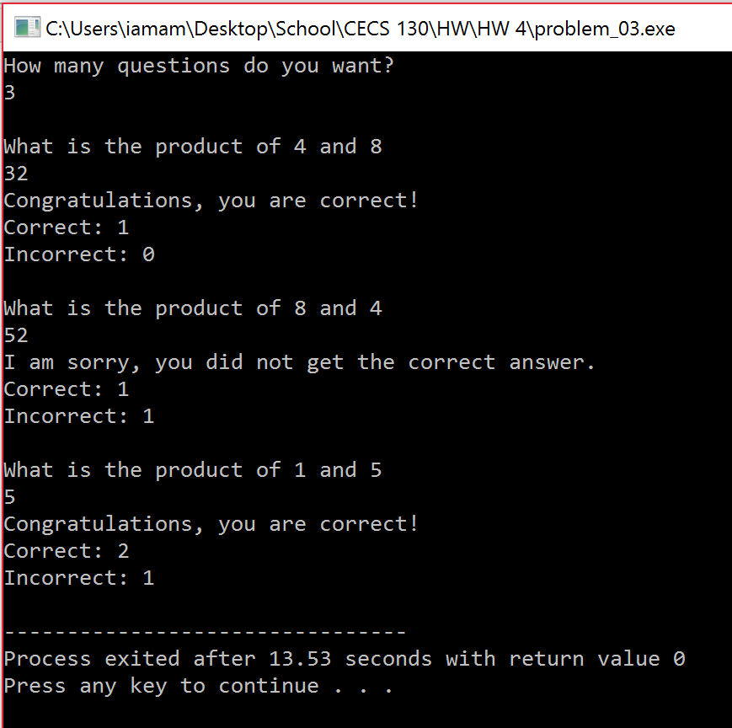

5-01-02.) I included both of the chapter 5 challenges in one file because I would have had to prototype the functions again in problem two regardless. My program successfully prototypes, defines, and calls the three functions specified in the prompt.

